Technology Certificate Project #1:
Get a gmail account, write an essay introducing yourself, email it to the teacher

- Get a g-mail account
  - For video instructions for how to get an account, go to

  - http://coultersc.weebly.com/
2
1
  - Click on Technology [1]
  - Under Internet, click on Email. [2] Watch the video on how to get a gmail account.
/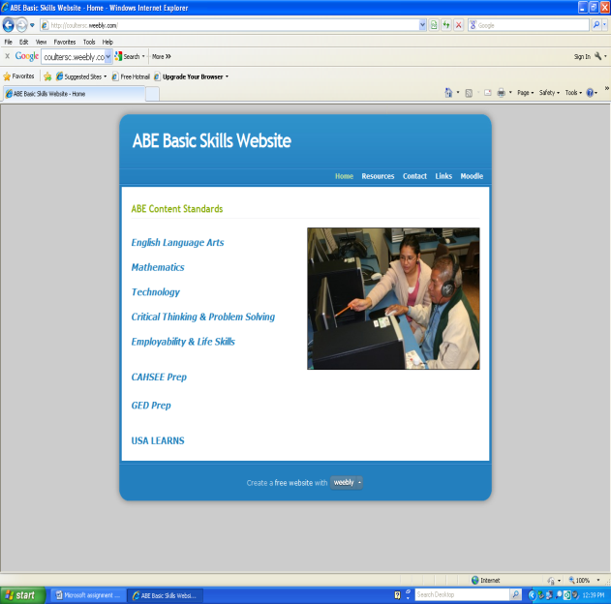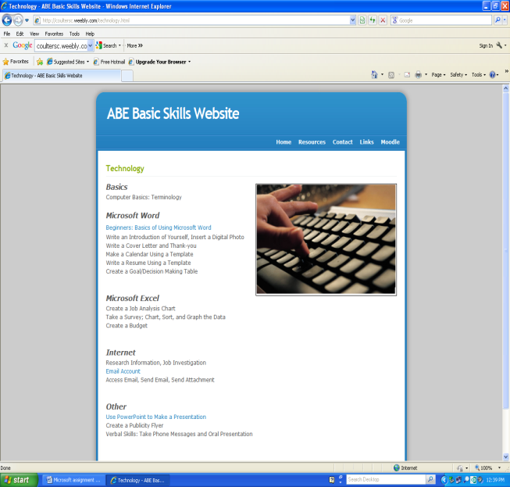
2
1
  - Get a g-mail account.
- Open Google Drive (Google: Google Drive) Enter your email address and password.[3] and [4]
- Write an essay introducing yourself. Click on Compose [5] and Document [6]
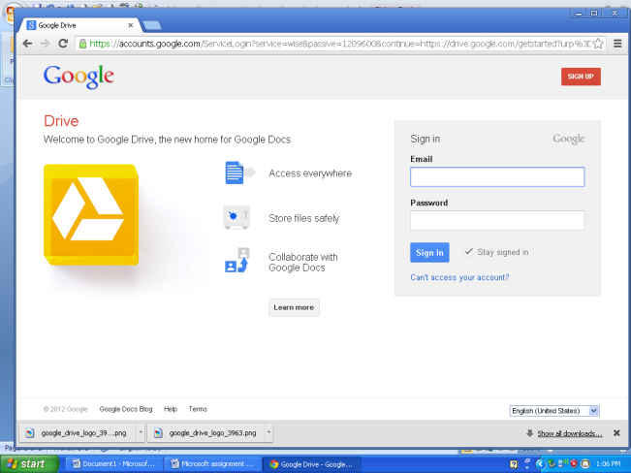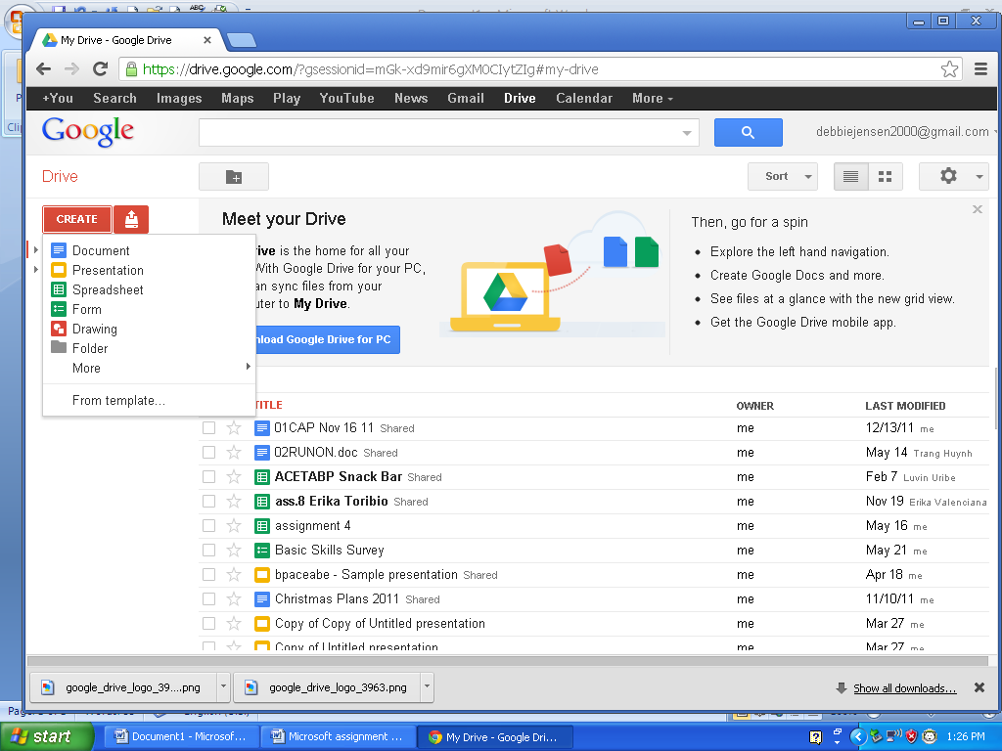
3
4
6
5
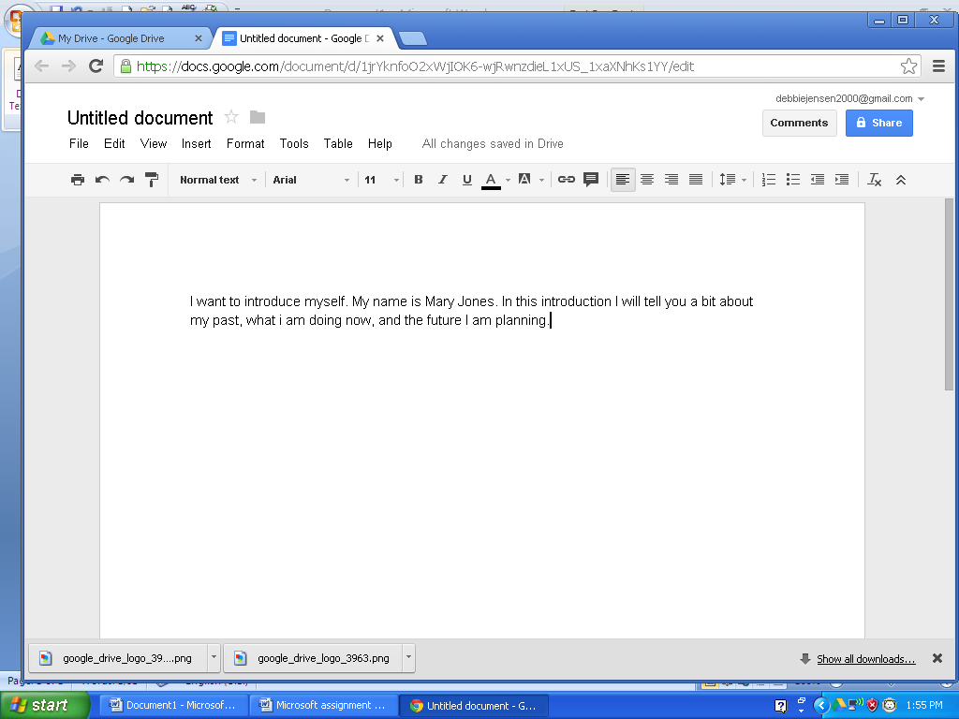
7
- Give your document a name: Click on File, [7], Rename your document: Your name Introduction.
- Send a copy to the teacher: debbiejensen2000@gmail.com
  - Click on file, scroll down to add people [8], add the teacher’s address.
  - Add a message. [9]Click on Share and Save. [10] Click on Done.
11
  - To Sign out: Click on arrow by your name [11]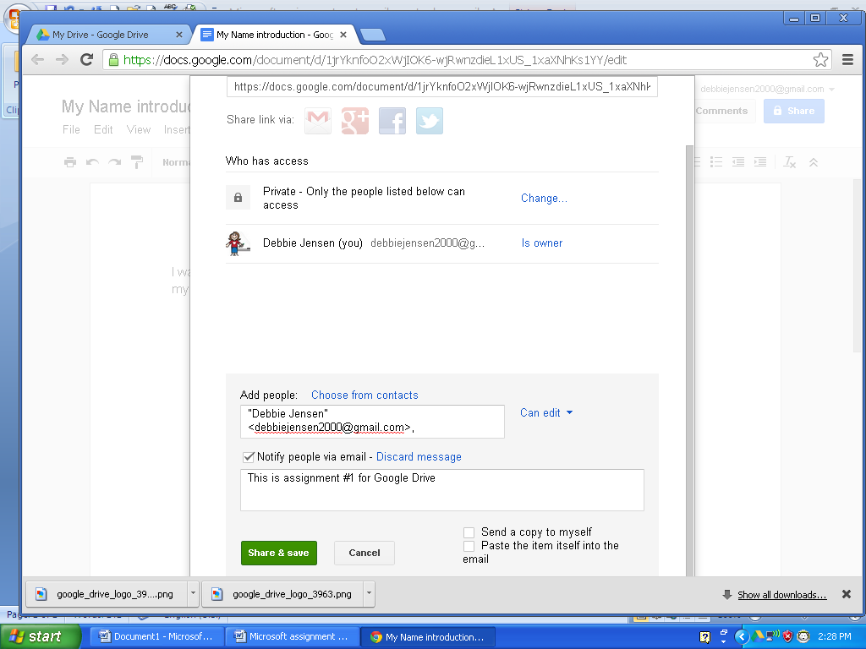
8
9
100

